BRUCE MAHERO
PERSONAL BIOGRAPHY & PROFESSIONAL MEDIA PORTFOLIO
Innovation Journalist | Media & Communication Professional
Nairobi, Kenya

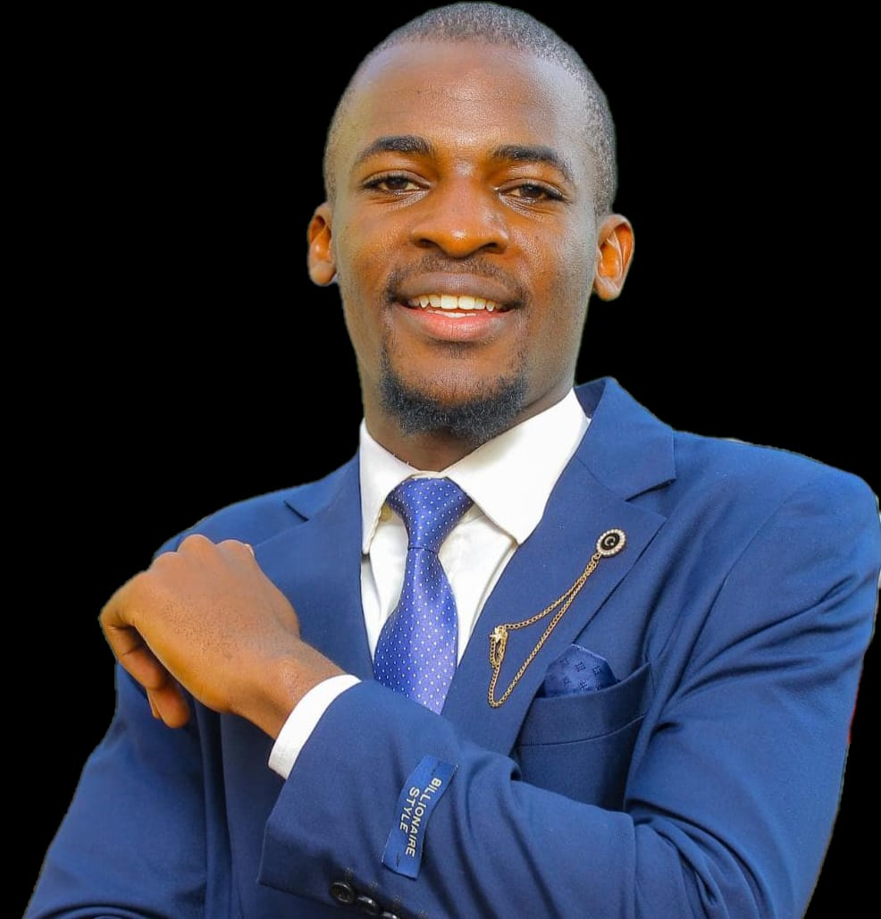

Professional Biography
Bruce Mahero is a prominent Kenyan journalist, media professional, digital communicator, and student leader whose work sits at the intersection of journalism, technology, information integrity, and youth leadership. He is pursuing a Bachelor's degree in Journalism at Zetech University and serves as President of the Journalism Students Association of Kenya (JSAK), leading the association's 4th Session National Executive Council.
His professional interests include innovation journalism, ethical reporting, fact-checking, artificial intelligence and the media, digital communication, and the development of the next generation of journalists in Kenya. Through his academic work, editorial contributions, industry engagements, and leadership responsibilities, Bruce is building a career centred on responsible storytelling, professional collaboration, and public trust.

1. Personal Life and Background
Bruce Mahero is based in Nairobi, Kenya. His educational journey began at Marenyo Primary School, continued at Butere Boys High School, and led him to university-level journalism studies at Zetech University.
Details about Bruce Mahero’s date and place of birth, family background, childhood, and early personal influences will be included where reliable sources are available and where he wishes to make those details public. His personal experiences and the circumstances that shaped his journey may also provide additional context to his development as a journalist, student leader, and emerging media professional.
Source for further verification: Nation Africa, Saturday Magazine, "“My Wife Walked Out on Us”" (https://nation.africa/kenya/life-and-style/saturday-magazine/my-wife-walked-out-on-us--585424).

2. Academic Journey

Marenyo Primary School
Bruce completed his primary education and attained 349 marks in the KCPE examinations.

Butere Boys High School
He completed his secondary education, attaining a mean grade of C+ in the KCSE examinations.

Zetech University | Undergraduate studies
Bruce is pursuing a Bachelor's degree in Journalism, developing competencies in reporting, broadcast production, news presentation, media law and ethics, digital storytelling, and multimedia communication.

3. Career and Professional Experience

Journalism and Media Production
Bruce is developing a multidisciplinary career in journalism, with interests spanning reporting, news anchoring, producing, editorial writing, and digital content creation. His approach combines traditional journalistic principles with the opportunities presented by digital platforms and emerging technologies.
- News reporting, interviewing, and feature writing.
- Broadcast production, news presentation, and multimedia storytelling.
- Innovation and technology journalism.
- Media law, ethics, verification, and accountability.
- Social media marketing, editorial content, and audience engagement.

Digital Media and Editorial Work
Bruce has contributed to EpicPulse Magazine through social media marketing and content development. His work involves supporting online engagement, communicating stories to digital audiences, and contributing to website content. His journalism interests include examining how artificial intelligence is changing newsroom practices and how journalists can balance innovation with accuracy, human judgment, and ethical responsibility.

Sports Journalism and Content Creation
Through content work with Zetech Sparks FC, Bruce has developed experience in sports communication, including match-day captions, team announcements, player recognition, match galleries, and post-match coverage.

4. Leadership Journey: JSAK
In October 2026, Bruce assumed office as President of the Journalism Students Association of Kenya (JSAK), 4th Session National Executive Council. His leadership journey progressed from representing Zetech University as a Chapter Representative to taking on national-level responsibilities. As President, he works with chapter representatives and the national secretariat to strengthen coordination, encourage collaboration, and support initiatives that benefit journalism students across Kenyan universities.
- Promoting collaboration among journalism students and university chapters.
- Encouraging practical learning, media innovation, and professional development.
- Supporting student engagement with media organisations and industry practitioners.
- Promoting ethical journalism, fact-checking, and information integrity.
- Strengthening communication and coordination across the association.

5. Professional Development and Industry Engagements

Africa Facts Summit 2026 | 21–22 October 2026
Bruce attended the Africa Facts Summit at Safari Park Hotel, Nairobi, under the theme “Information Integrity in an Ever-Evolving Landscape: AI, Agency, and Influence in Africa.” The event explored misinformation, artificial intelligence, information integrity, and the responsibilities of media professionals.

Building Information Resilience Against FIMI in Kenya — Workshop Training I | 29–30 June 2026
Bruce completed a two-day professional development workshop organised by Africa Check in partnership with the European Union External Action at Mövenpick Nairobi. The training focused on fact-checking, verification, and strengthening resilience against Foreign Information Manipulation and Interference (FIMI).

6. Published Articles and Writing Portfolio

Preparing the Next Generation of Journalists for the AI Era: Balancing Innovation, Ethics and Trust
Reported as published in The Standard on 21 August 2026. The article examines preparing future journalists for an AI-enabled media environment while maintaining professional ethics, verification, and public trust.
[ https://www.zetech.ac.ke/index.php/latest-events/empowering-learners-for-the-ai-era-through-digital-fluency-and-security-awareness // https://lnkd.in/p/dzGXeq8J ]

Award-winning Feature Story
Bruce received first place in the Best Feature Story category at the JSAK Annual Media Awards. Add the original story title, publication, date, and link here.
[https://epicpulse.co.ke/dennis-irungu-building-systems-africa-can-rely-on/.]

Additional Publications
EPICPULSE MAGAZINE https://epicpulse.co.ke/author/bruce-mahero/
DATAPOINT DAILY https://datapointdaily.co.ke/authors
THE BOLD EAST AFRICA https://theboldeastafrica.com/author/BRUCE%20MAHERO
ZETECH UNIVERSITY BLOGS https://www.zetech.ac.ke/

7. Awards and Certificates

First Place — Best Feature Story | JSAK Annual Media Awards
Recognised for feature writing, receiving a gold medal and a certificate of appreciation while representing Zetech University.

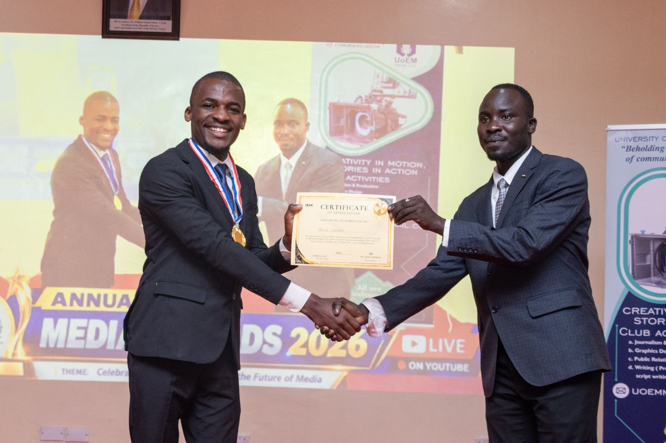

Certificate of Completion — Building Information Resilience Against FIMI in Kenya, Workshop Training I
Completed 29–30 June 2026. Organised by Africa Check in partnership with the European Union External Action. The workshop addressed information verification, fact-checking, and resilience against foreign information manipulation and interference.
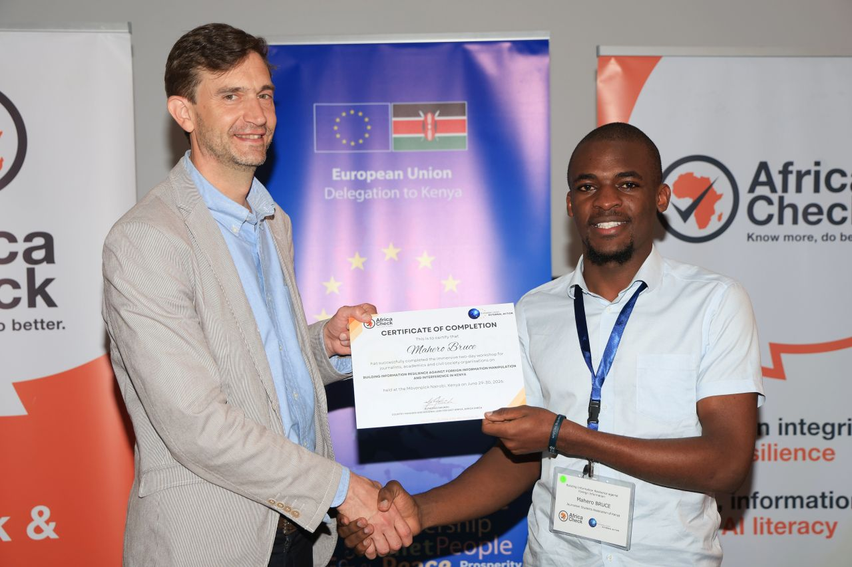.

8. Photography and Visual Archive
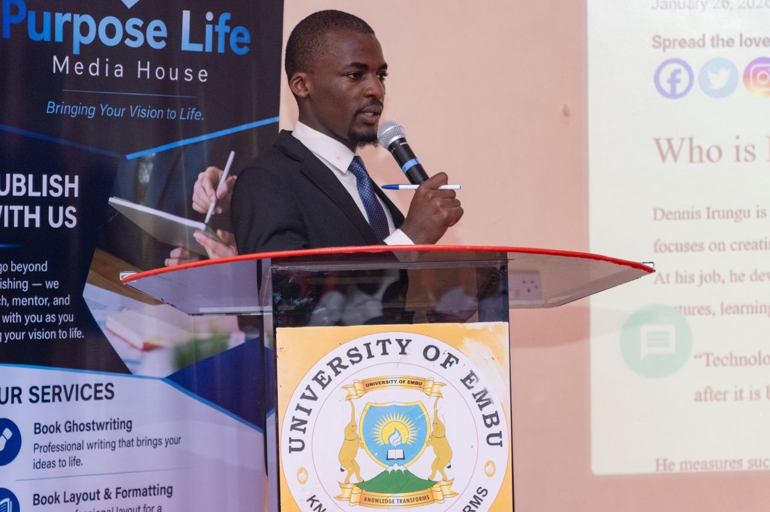
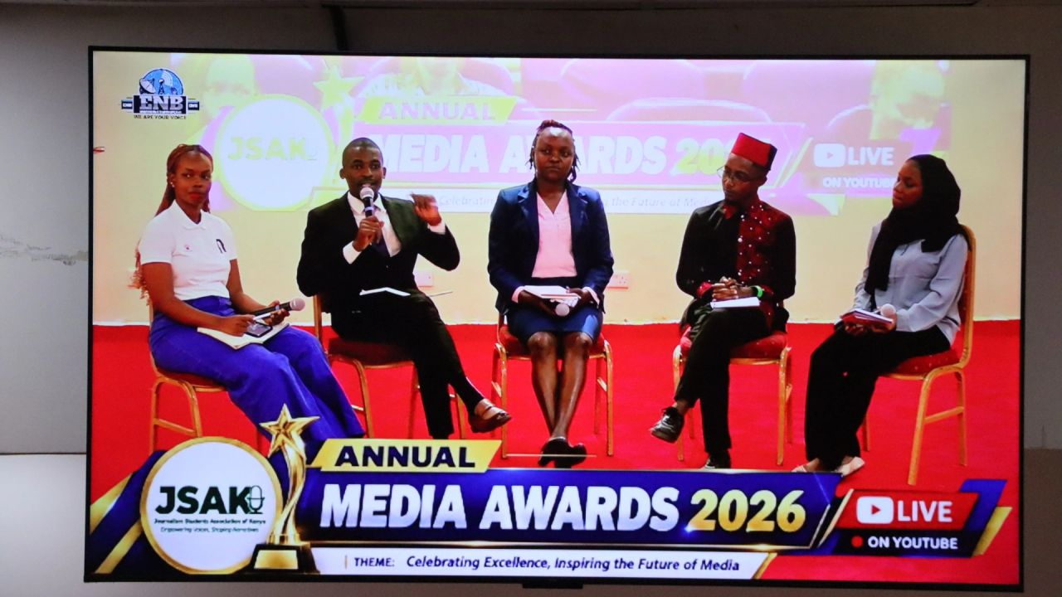
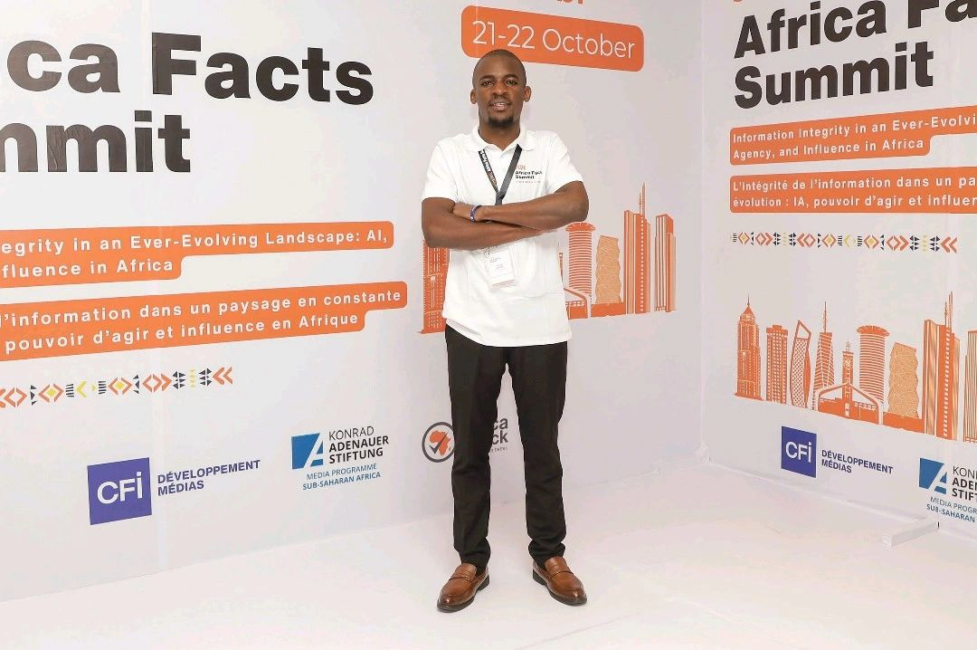[
[]

9. Professional Contacts and Online Presence
Location: Nairobi, Kenya
Email: brucemahero@zetech.ac.ke
LinkedIn: https://www.linkedin.com/in/bruce-mahero-034072359/
Website: …
Facebook: https://www.facebook.com/thee.bruletz/
X; https://x.com/brucemahero
Instagram; https://www.instagram.com/brucemahero/

10. Personal Philosophy and Signature Quote
“The future of journalism belongs to those who embrace innovation, uphold integrity, and remain committed to the truth.”
— Bruce Mahero --

11. Vision for the Future
Bruce aspires to contribute to the development of journalism in Kenya and across Africa by embracing innovation while defending the principles that make journalism valuable to society. He is interested in how emerging technologies can improve storytelling, strengthen verification, and expand access to reliable information without replacing human judgment or professional accountability. Through journalism, leadership, digital communication, and continued professional development, he aims to support a media environment that is credible, innovative, inclusive, and responsive to the public interest.


Africa Public Relations Week 2026 -
"Cards on the Table" at IMAX at Garden City

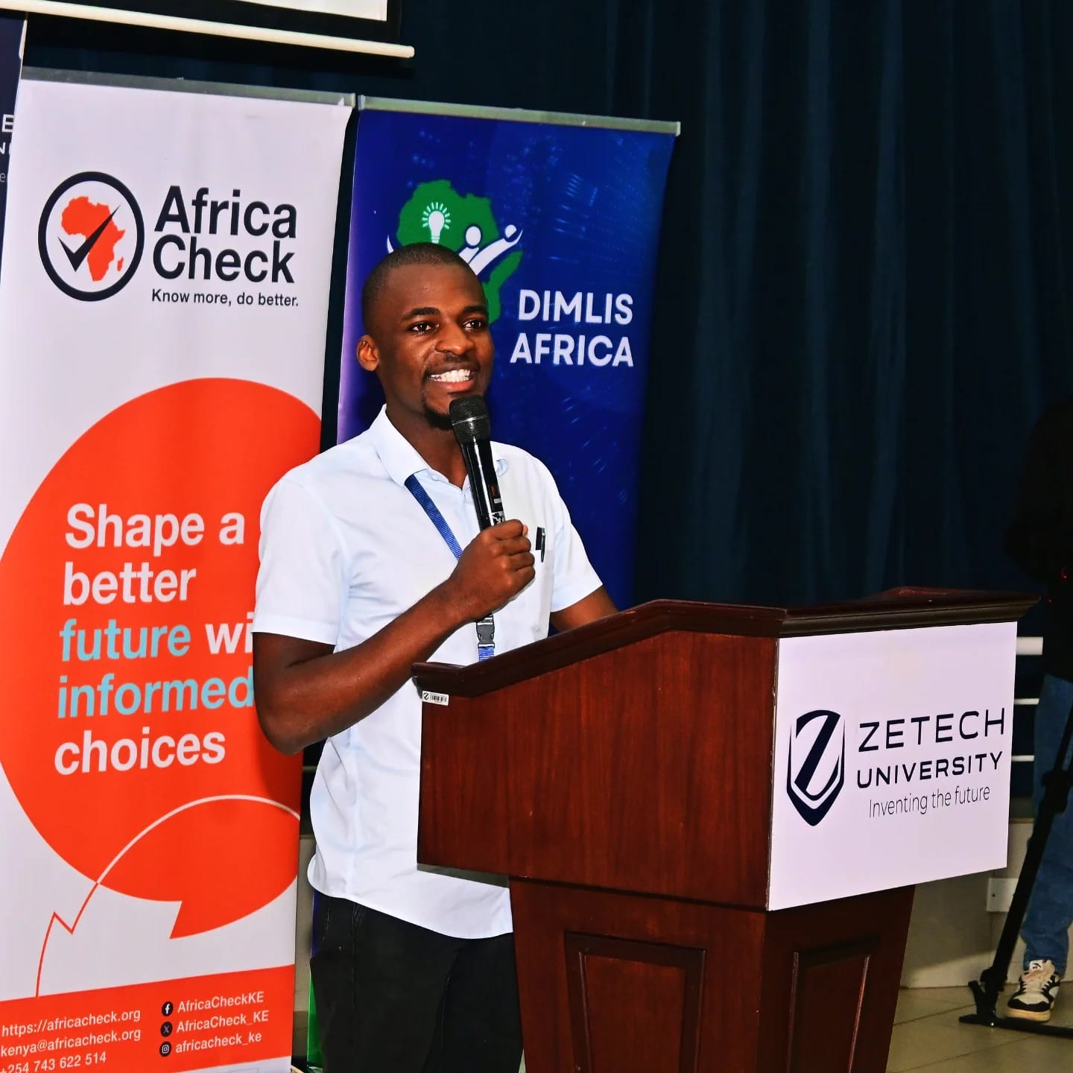
Speaking at Zetech University during the National Fact-Checking BootCamp

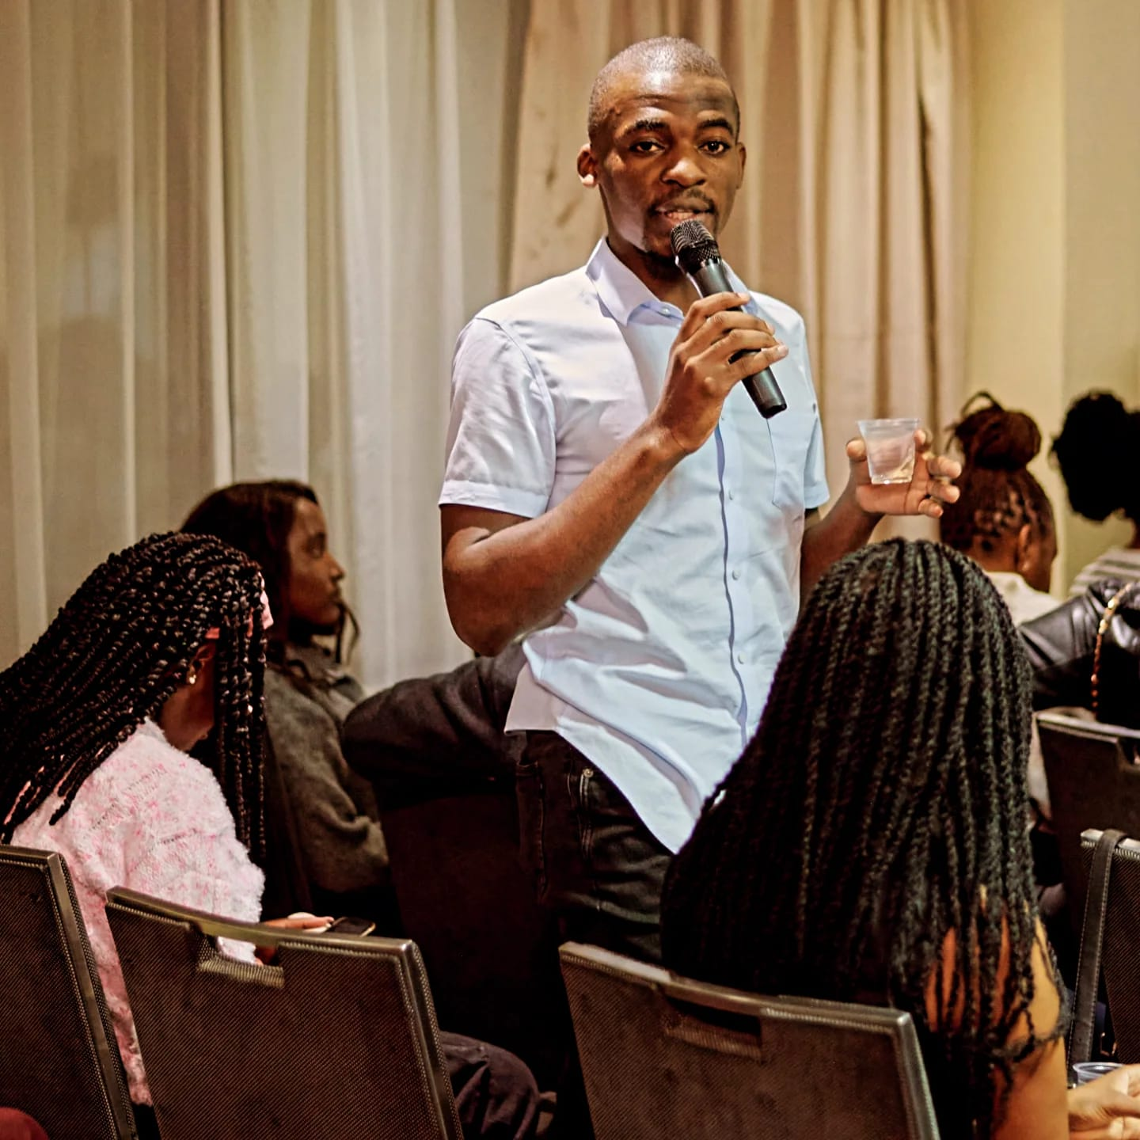
Speaking at the Film and Screening Night hosted at the Clarion Hotel by the Rotaract Club Nairobi

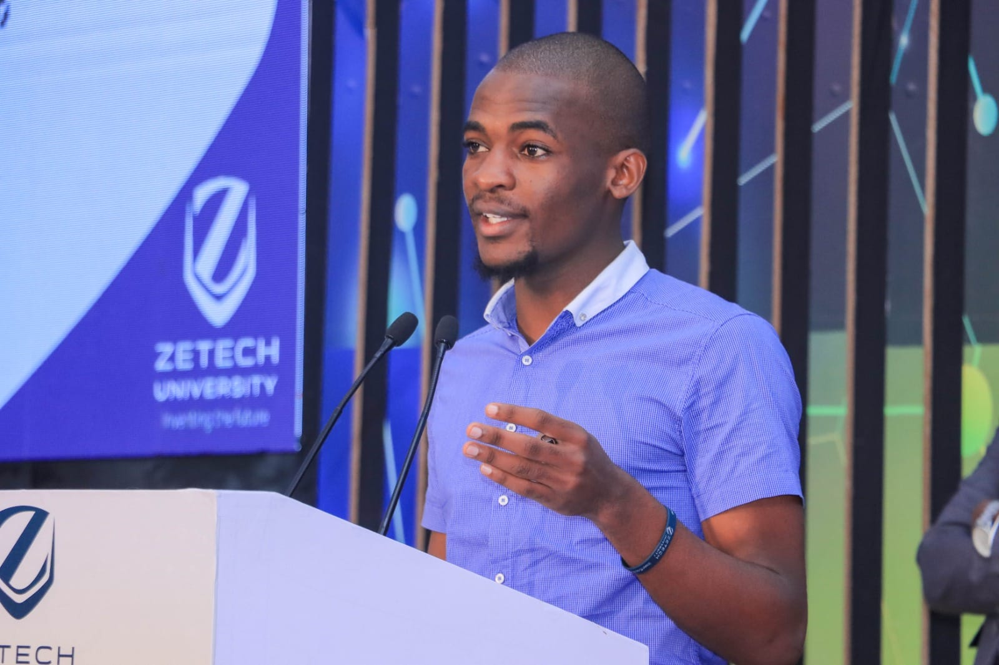
Speaking at Zetech University during the Eighth Research and Innovation Week



